DNS and Route 53 for Domain Management

What is route53
route 53 is a global service provided by amazon aws which works on the DNS that resolves ips to name and name to ips as well as it register the new domains, transfer the existing domains and route the traffic for your domain as well as monitor the health of our resources.
Route 53 Functions
- DNS Management
- Traffic Management
- Availability Monitoring
- Domain Registration

AWS supports Two Types of TLD
- Generic top-level domains (.com, .in, .net)
- Geographic top-level domain (.IN, .us, .un, .uk)

DNS Working

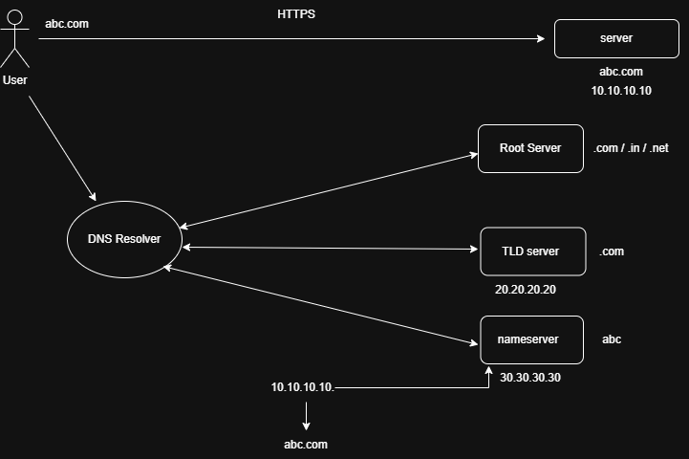
What Is Hosted Zone
- A Route 53 hosted zone is a collection of records for a specific domain.
- Whenever we create a hosted zone for a specific domain the SOA and the ns server record is automatically created.
Types Of Hosted Zone
- Public hosted zone
1.Public hosted zone is used to route traffic over the internet
2.Accessible globally

- Private hosted zone
1.Private hosted zone is used to route traffic inside the vpc.
2.Only works for internal AWS resources

RECORDS TYPES
- A record- Map domain name to IPv4 Address
- AAAA record- Maps domain name to IPv6 address
- CNAME- Map One domain to another domain
- NS record- Tells which server manages the domain
- SOA record- start of authority record (Having all info the about the domain)
- MX record- Defines where to deliver mail for user@ a domain name.
- CAA- Which company can issue SSL certificate
- PTR- Reverse of A record (IP → domain name)
- SPF- Tells which servers can send emails for your domain
- Alias- one domain name points to another AWS resource

